Answers 3.7

**STEP 1:**

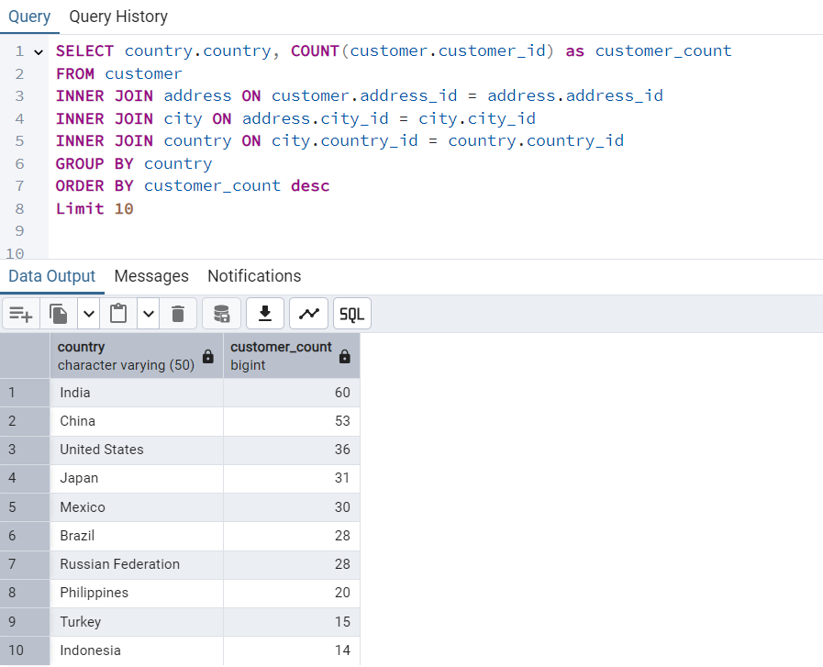

**CODE:**

SELECT country.country, COUNT(customer.customer_id) as customer_count

FROM customer

INNER JOIN address ON customer.address_id = address.address_id

INNER JOIN city ON address.city_id = city.city_id

INNER JOIN country ON city.country_id = country.country_id

GROUP BY country

ORDER BY customer_count desc

Limit 10

**Approach:**

1. Identify the necessary tables: The customer table contains customer data, but the country information is in the country table.
2. Establish relationships: Used INNER JOIN to connect customer - address - city - country.
3. Aggregation: Used COUNT(customer.customer_id) to count customers per country.
4. Sorting & Limiting: Ordered results in descending order and limited to the top 10 countries.

**STEP 2:**

**CODE:**

SELECT city.city, country.country, COUNT(customer.customer_id) as customer_count

FROM customer

INNER JOIN address ON customer.address_id = address.address_id

INNER JOIN city ON address.city_id = city.city_id

INNER JOIN country ON city.country_id = country.country_id

WHERE country.country_id IN (SELECT country.country_id

FROM customer

INNER JOIN address ON customer.address_id = address.address_id

INNER JOIN city ON address.city_id = city.city_id

INNER JOIN country ON city.country_id = country.country_id

GROUP BY country.country_id

ORDER BY COUNT(customer.customer_id) DESC

LIMIT 10)

GROUP BY city.city, country.country

ORDER BY customer_count DESC

LIMIT 10

**Approach:**

1. Built on the first query by focusing on cities instead of countries.
2. Used a subquery to filter cities from countries that have the most customers.
3. Ensured correct grouping by including both city.city and country.country in GROUP BY.
4. Ordered the results based on customer count to get the top 10 cities.

**STEP 3:**

**CODE:**

SELECT customer.customer_id, customer.first_name, customer.last_name, city.city, country.country, SUM(payment.amount) AS total_amount_paid

FROM payment

INNER JOIN customer ON payment.customer_id = customer.customer_id

INNER JOIN address ON customer.address_id = address.address_id

INNER JOIN city ON address.city_id = city.city_id

INNER JOIN country ON city.country_id = country.country_id

WHERE city.city IN(SELECT city.city

FROM customer

INNER JOIN address ON customer.address_id = address.address_id

INNER JOIN city ON address.city_id = city.city_id

INNER JOIN country ON city.country_id = country.country_id

GROUP BY city, country

ORDER BY COUNT(customer.customer_id) desc

Limit 10)

GROUP BY customer.customer_id, customer.first_name, customer.last_name, city.city, country.country

ORDER BY total_amount_paid DESC

LIMIT 5

**Approach:**

1. Filtered customers based on the top 10 cities from the second query.
2. Included payment data by JOIN the payment table to get total spending per customer.
3. Grouped by customer ID to ensure aggregation worked correctly with SUM(payment.amount).
4. Used a subquery in WHERE city.city_id IN to get the top 10 cities with the most customers.
5. Sorted by spending and limited to the top 5 customers